FRONT COVER



**GOLF**

**Golf is played, for the most part, without the supervision of a referee or umpire. The game relies on the integrity of the individual to show consideration for other players, care for the course and to abide by the Rules.**

**All players should conduct themselves in a disciplined manner, demonstrating courtesy and sportsmanship always, irrespective of how competitive they may be.**

**This is the spirit of the game of golf.**

***And this is your Club***

**BOARD OF DIRECTORS** As at 16th November 2020

|  |  |  |  |  |  |  |  |  |  |
| --- | --- | --- | --- | --- | --- | --- | --- | --- | --- |
| |  |  | | --- | --- | | **President** | Adrian King | | **Vice-President** | David Devney | | **Treasurer** | David Chomley | | **Captain** | Teresa Munro | | |
|  |  |
| **DIRECTORS**  Phil Burey, Gavin Bartel,  Shane Brooker, Ken Wharton, Mick McLaren | |
|  |  |
| **SUB COMMITTEES and Responsibilities.**  **Finance Committee:**  Adrian King, David Chomley, David Devney  **Greens Director:**  Phil Burey  **Match Committee:**  Board of Directors & David Wright  **House and Social Director:**  Mick McLaren  **Handicapper: -** Ken Wharton  **Ladies Golf:** - Julie Rushby  **Patrons:** George Kabel & John Reynolds  **Life Members:** Rex Mitchell, Peter Webb, John Reynolds & Gerald Humphries | |

**North & North West District Golf Associates Association**

|  |  |  |
| --- | --- | --- |
| Barraba | Bellata | Bingara |
| Boggabri | Coonabarabran | Curlewis |
| Gunnedah | Mungindi | Narrabri |
| Nundle | Quirindi | Spring Ridge |
| Tamworth | Wee Waa | Werris Creek |
|  |  |  |

**GUIDELINES**

The following information is provided for all members so that the enjoyment of the Club’s facilities will not be impaired by any Club Member or Visitor. Further information is set out in the By-Laws and Constitution of the Club.

**RULES OF GOLF**

Rule books are available from the office and members are reminded that it is their responsibility to know them all and adhere to them.

**LOCAL RULES**

To be read in conjunction with the Rules of Golf. These are listed on all score cards. Additions may be posted on the Notice Boards as required.

**PLAYING RIGHTS**

1. In the absence of special rules, two ball matches have precedence over and are entitled to pass any three or four ball matches.
2. A single player has no standing and should give way to a match of any kind.
3. Any match playing a whole round is entitled to pass a match playing a shorter round.
4. On Club Competition days, competitors have the right of the course.

**THE PACE OF PLAY HAS BEEN DETERMINED AT A MAXIMUM OF**

**2 HOURS AND TEN MINUTES PER NINE HOLES.**

**BREAKS ARE LIMITED TO 10 MINUTES.**

**COURTESY ON THE COURSE**

**Each member is asked to give close attention to**

1. **The Rules of Golf**
2. **The Etiquette of the game**
3. **The local Rules**
4. **The Regulations Governing Conditions of Play**

* All matches are played over 18 holes unless stated.
* Players should play without delay.
* It is a group’s responsibility to keep up with the group in front.
* Penalty for slow play (2 strokes) may be imposed.
* A Player, on losing his/her ball, MUST immediately call the players through and then only THREE minutes is allowed to look for the ball.
* If a player believes his/her ball may be lost outside (Out of Bounds) or is in a Penalty area, to save time, he/she should play a provisional ball - and must announce “Provisional”.
* When playing on or near the putting green, players should leave their bags or carts in such a position as will enable quick movement away from the green and towards the next tee.
* Players are obliged to move off the putting green before marking their cards.
* Players are obliged to pick up if they fail to score.
* Players should ensure that no one is standing close by or in a position to be hit by the club, the ball or other objects when they make a stroke or practice swing.
* Players should not play until the players in front are out of range.
* Players should always alert greens staff nearby or ahead when they are about to make a stroke that might endanger them.
* If a player plays a ball in a direction where there is a danger of hitting someone, they should immediately shout a warning – the traditional word of warning in such situations of “FORE”.
* Players should always show consideration for other players on the course and should not disturb their play by moving, talking or making unnecessary noise.
* Players should not stand close to or directly behind the ball, or directly behind the hole, when a player is about to play.
* Players should ensure that any electronic device taken onto the course does not distract other players.
* A player who had the honour should be allowed to play before their opponent tees their ball.
* On the teeing ground, a player should not tee their ball until it is their turn to play.
* On the putting green, players should not stand on another player’s line of putt nor cast a shadow over the line of putt during a stroke.
* Players should remain on or close to the putting green until all other players in the group have holed out.

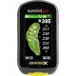**MEASURING DEVICES -GPS**

**For all play at this course a player may obtain distance information by using a device that measures distance only.**

**If, during a stipulated round, a player uses a distance-measuring device that is used to gauge or measure other conditions that might affect his or her play (e.g. gradient, wind speed, temperature etc) the player is in breach of Rule 14-3, for which the penalty is disqualification, regardless of whether any such additional function is used.**

**CARE OF THE COURSE**

* **Through to the green a player should ensure that any turf cut or displaced by them is replaced at once and pressed down.**
* **Players should carefully repair any damage to the putting green made by the impact of a ball, (whether or not made by the player themselves).**
* **On completion of the hole by all players in the group, any damage to the putting green caused by golf shoes should be repaired.**
* **Players should avoid causing damage to the course by removing divots when taking practice swings or by hitting the head of a club into the ground, whether in anger or for any other reason.**
* **Players should ensure that no damage is done when putting down bags or the flagsticks.**
* **Players and caddies should not stand too close to the hole and should take care during the handling of the flagstick and the removal of the ball from the hole.**
* **Local notices regulating the movement of golf carts should be strictly observed.**
* **NO carts are allowed on the greens or within 6 metres of any green. Where greens have been marked with a black line, players can be disqualified for crossing that line with their Golf Cart.**

# **MOTORISED & ELECTRIC CARTS.**

* **Cart owners and hirers are responsible for the use of their cart at all times.**
* **Drivers must be at least 17 years of age.**
* **Carts must use designated cart paths and obey directional signs.**
* **Carts MUST NOT be driven within 6 Metres of the greens, or intentionally across designated black lines - if reported penalties will apply and players could face disqualification.**
* **Carts are to utilise the course tracks where ever possible – preference is to use the tree lines where ever possible.**
* **Cart users should take all efforts to avoid wet patches and irrigation hoses.**
* **Players using carts must maintain their normal place in the field and will have no special priority.**
* **Cart users should treat all players about to hit or putt with courtesy.**
* **Cart users should ensure that green staff are always given right of way on the course.**
* **The Board to minimise compaction, would appreciate members sharing carts rather than having 3 or 4 carts in any one group.**

**Failure to observe these conditions may result in withdrawal of permission to use the cart on the course.**

*Elders Insurance*

*Proudly Sponsoring*

*Mens & Ladies*

*Eclectic Competition*

**An eclectic tournament is a multi-round Golf tournament that results in one 18-Hole score per player. For every round you play, only the best score on each and every hole is kept. You end up with one eclectic card showing all your best scores for the rounds you played within the specified period. That is their eclectic score.**

**Eclectic Commencing on 1st March 2021**

**Cost $10 Entry per player**



RISK WARNING

Lightning

**At any time there is lightning activity and there is a significant risk of being struck by lightning on a golf course.**

**It is your responsibility to check weather forecasts and to ensure your own safety regarding lightning before you use the golf course.**

**It is a condition of entry to this course that you acknowledge that you do not rely on us to ensure your safety from lightning.**

RISK WARNING

Calling up on Par 3’s

**Playing golf involves inherent risks, including the risk of being struck by a golf ball. The risk of being struck by a golf ball is significantly increased if players “call up” the following group on a par 3 hole.**

**Calling up on par 3 holes is not permitted on this course.**

**Any player calling up a following group is in breach of this policy and does so at the player’s own risk and may not be covered by insurance.**

Our Green Staff have right of way

**Work Health and Safety**

**Green staff always have the right of way. Do not hit up on or perform any act that may place them in danger.**

**Do not hit up on other competitors or our green staff as injury to them could prove expensive to you.**

**COMPETITIONS CARDS**

**Day Light Saving Times: all cards returned by 6.00 p.m.**

**Winter: all cards returned by 5.30 p.m.**

**Cards handed in after these times may be disqualified.**

**PRACTICE ON THE COURSE**

Members playing a practice round on the course are permitted to play two balls only during the play of any one hole.

Players practicing on the course are reminded that competitors have the right of the course. At no time should a player ‘cut in’ on any hole when players are on the previous green.

**COMPLAINTS**

All complaints shall be made in writing to the Manager of the Club who shall submit them to the committee.

No employee of the Club shall be directly reprimanded by any individual member.

**DRESS RULES**.

* Clean, neat collared shirt, dress shorts or slacks may be worn with walk socks or sport socks.
* Football shorts, football socks, stubbies or tracksuit pants will not be permitted on the course.
* Golf shoes or sports shoes must be worn.
* Ladies should observe similar dress code.
* Clean, reasonable working attire will be accepted throughout the club 7 days a week.

**MATCH COMMITTEE GUIDELINES**

**Grades:**

**Men A -5 - 11 Ladies A -5 - 22**

**B 12 - 17 B 23 - 32**

**C 18 - 36 C 33 - 45**

**\* The grades may change throughout the year at the discretion**

**of the Captain.**

**HANDICAPS**

**Players will not be required to play a minimum number of rounds each year in order to maintain the GA Handicap.**

Members are responsible for the correctness of their own handicap and should keep a personal record of scores submitted for handicap through the year.

1. **INDIVIDUAL.**
2. Handicap Match Play: full difference of handicaps
3. **FOURSOMES (Includes Mixed)**
   1. Stroke: Half of combined handicaps
   2. Canadian: Half of combined handicaps
   3. American: Half of combined handicaps
4. **AMBROSE**
5. 2 Person: 1/4 of combined handicap
6. 3 Person: 1/6 of combined handicap
7. 4 Person: 1/8 of combined handicap

**Handicap Limits**:

Men 36 - Ladies 45

**LOCAL COMPETITIONS:**

**MID-WEEK COMPETITIONS**

Tuesday Medley: 9 Hole Pro Shop Event

Wednesday Summer: 4 Person Ambrose

Winter: Pro Shop Ball Competition

Thursday Veterans, Ladies and Young Guns

( online bookings)

Friday 9 Hole Pro Shop Event.

**These competitions are subject to change – all players are required to report to the Proshop before entering the course.**

**WEEKEND COMPETITIONS.**

**Members are advised that computerised Nominations are only via online for all competition rounds. Members are responsible for entering their scores on the touch screen located at Captain’s Corner.**

**Nominations should be made well in advance via online booking, although telephone nominations will be accepted on the day of play at the discretion of the Pro Shop Staff (02 67 52 1480)**

**Subscriptions**

**The Financial Year for all members is from the 1st August to 31st July.**

**Subscriptions are due and payable by 31st August,**

**as determined in the current By-Laws.**

**Members who are in arrears regarding payment of fees cannot retain membership privileges and cannot take part in Club Golf Competitions.**

**Patron’s Four Ball Knockout.** This is a Four Ball Match Play handicap

event. As this event is a knockout competition, matches must be played on or before the date set down on the programme or the match is forfeited.

* **Sponsored by The Patrons.**
* **Ladies Fourball Matchplay**

**Sponsored by Julie Rushby and Debbie Evans**

**Silvertails Trophy.** This is a single match play event. As this event is a knockout competition, matches must be played on or before the date set down on the programme or the match is forfeited.

* + **Sponsored by Stephen Sparke Jewellers.**
  + **Ladies Single Matchplay**

**Sponsored by Trim Munro**

**RULES:**

1. **Matches are to be played on or before the due date.**
2. **All players are to advise their mobile phone number so that the player on top of the match must contact their opponent.**

**Men’s Monthly Mug, Sponsored By Gwydir Glass & B&W Rural**

Will be played on the days set down in the programme. Winner will be the player who returns the best nett score on the day. The twelve (12) months winners will play in the Mug Play Off.

* + **Ladies equivalent is Monthly Medal.**
  + **Sponsored by Dippers Home Timber and Hardware.**

**Summer 2 Ball Better Ball** is played over six (6) rounds with the best four of six rounds tallied for a result. Teams must have played at least four rounds to be eligible. Net and Gross 2 Ball winners’ trophies will be awarded.

**Eagles Nest**. Accumulates by 1 ball on each day of the weekend where there is a Golf Club competition day.

**Eagles Nest.**

**A person is entitled to the balls in the eagles’ nest “bucket” if**;

1. They are a full playing member of the Moree Golf Club at the time they got the eagle. (It is the members who contribute to the balls over the full year.)
2. It was in an event that;
3. Is in the programme booklet i.e., (played on Saturday, Sunday, Thursday and Public holidays)
4. is at least 18 holes
5. was obtained by playing the shot from the normal placing of the tee area
6. It was in an event that;
   * 1. They got the eagle on a par 4 hole or an albatross on a par 5 hole.

**Hole –in-one.**

**A person will win 1 dozen golf balls plus a Moree Golf Club Shirt if:**

1. They are a full playing member of the Moree Golf Club at the time they got the hole in one. (It is the members who contribute to the balls over the full year.)
2. It was in an event that;
3. Is in the programme booklet i.e. (played on Saturday, Sunday, Thursday and Public holidays or any Charity Day approved by the Board)
4. is at least 18 holes
5. was obtained by playing the shot from the normal placing of the tee area i.e. would not be entitled to it if they got a hole in one on the second hole in the 27-hole par three competition.

**Junior Championships**. Players must be under 18 years of age prior to the commencement of play. This event will be played in conjunction with Club Championships.

**Veteran Championships**. Men must be 55 years or older prior to the commencement of play. This event will be played in conjunction with the Club Championships. Ladies must be 50 years of age or older.

**Match Play**

* + **Singles**: The difference between the full handicaps of the two players.
  + **Four Ball**: Back markers to concede strokes to other three players based on the difference between the full handicaps. Strokes to be taken according to the stroke table.
  + **Stroke Play**
* **Singles:** Full handicap.
* **Four Ball**: Each player receives the full handicap and strokes to be taken according to the strokes index.
* **Foursomes:** Half of the aggregate handicaps of the partners.

**Proud Sponsors of the Thursday Veterans Golfer of the Month**

**SCORING**

**There are very definite rules laid down in respect to the marking of score cards and it is every player’s duty to become acquainted with the correct method.** If you are not sure, or don’t know, then ask the Captain or Day Captain.

**The marker has the responsibility to ensure that a player’s score is recorded correctly.** Make a habit of counting your opponents’ strokes just as you would count your own. If you think a breach has been made and are in doubt as to the procedure, refer it to the Match Committee as soon as you complete your round and before giving your card to the player for handing in.

**Once handed in, a card cannot be reclaimed for alterations or amendments, and if inaccurate immediately incurs a penalty and or disqualification.**

The player is responsible for the accuracy of their card. Before your card is handed in, make sure that your handicap is stated correctly, that the score for each hole is correct and that the card is signed.

**NEW MEMBERS**.

It is the desire of the Board of Directors that proposers of new members do everything to encourage new members,

particularly:

* **Introduce them to other members.**
* **Advise them of the rules of golf and the Club.**
* **The conduct and dress that is required.**
* **And to do everything possible to make their membership enjoyable and an advantage to the club.**

**



and B & W Rural



2/57 Heber Street, Moree, NSW, 2400

Proudly Supporting Ladies Golf

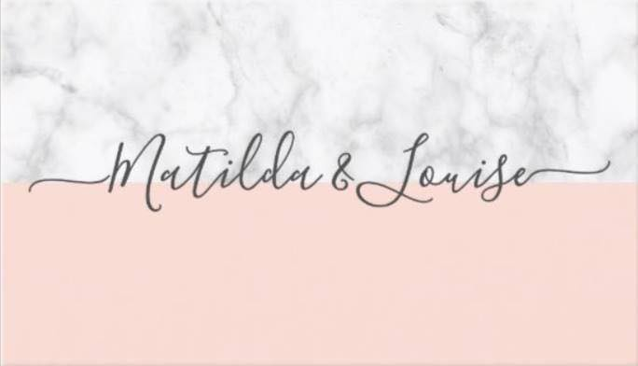

and B & W Rural

**Taubro Ag**

**Proudly Sponsoring**

**a selection of events**



and B & W Rural

6/113 Balo Street Moree, NSW, 2400

www.rubysolesmoree.com





Proudly Supporting Ladies Golf



and B & W Rural

Campbells Fuel Service

Continued

Sponsors of the Moree Men’s Open



and B & W Rural

**Tremendum Ag Partnership**

***Proud Sponsors of Various Events***





B&w Rural & Gwydir glass

Sponsors of Men’s Monthly Mug

& Annual Playoff



and B & W Rural



***Sponsors of***

***36 Hole 4BBB Stableford Championships***

D**ipper’s**

**Home Timber**

**& Hardware**

398 Warialda St  
Moree, NSW 2400  
Ph:

02 6752 2233

**Proud Sponsors of Ladies Monthly Medal**

**& Club Championships**

and B & W Rural

Valued Sponsors of The Club Championships



**Moree Golf Club Major Sponsors:**

B & W Rural

Campbells Fuel Service

Dippers Home Timber & Hardware

Gary & Leigh Taunton

Gerard & Brenda Carrigan

Gwydir Spray Shop

Gwydir Glass

Heathfield Pastoral Co.

John & Kay Gillan

Nutrien

National Ag/Powermaster Batteries

Pitman Deakin

RL & TJW Onus

Taubro Ag

Tremendum Ag

Westpac

**The Moree Golf Club appreciates the generosity of**

**ALL our sponsors and supporters of Golf**



and B & W Rural



Proudly Supporting Ladies Golf

54 Heber Street Moree, NSW

Ph: 0477 720 334

E: info@pr-interiors.com.au





Sponsoring Ladies Open 4BBB





and B & W Rural



and B & W Rural



**458 Frome Street Moree, NSW 2400**

Telephone: 02 6752 8022 Fax: 02 6752 8099

Mobile: 0428 528 023

**Assef’s Moree**

**A Valued Sponsor of our**

**2 Ball Better Ball Summer/Autumn Competition**



and B & W Rural



and B & W Rural







MOREE PRO SHOP

**David Wright**

Your local Club Professional and Member of the Australian PGA.

Please talk to David for all your:

* Club fittings
* Stockists of all major brands at very competitive prices
* Lessons
* Group and personal tuition by appointment
* Full repair service
* Gift Vouchers

**Call David on 6752 1480 and you can find the Pro Shop on Facebook - Moree Pro Shop**

Log on to: [www.moreegolfclub.com.au](http://www.moreegolfclub.com.au)

Email: [moreeproshop.2400@gmail.com](mailto:moreeproshop.2400@gmail.com)

**PH: 02 6752 1480**

**BE WISE – BE PRO SHOP ADVISED**

**LOCAL RULES**

1. **OUT OF BOUNDS** – Balls lying outside all boundary fences or areas defined by black and white pegs and the gutter line of the LOWER practice putting green.
2. **PATHS AND ROADS** – Those paths which are surfaced with gravel or crusher dust, through the green, shall be treated as obstructions, and relief may be taken in accordance with Rule 24-2b
3. **GUR** – Is all areas marked with white lines or indicated by white pegs, or GUR Sign.
4. **PENALTY AREAS**: Are defined as either red or yellow markers. For one penalty stroke, you may use specific relief options to play a ball from outside the penalty area please refer to Rule 17 (Player’s Edition of the Rules of Golf.)
5. **BARE PATCHES** – A ball coming to rest on a bare patch that is larger than your open scorecard (approx 20 cm sq) on the closely mown surface only – ball may be lifted, cleaned and dropped WITHIN ONE CLUB LENGTH without penalty. This does NOT include divots and sand-filled divots)
6. **WEATHER CRACKS** – In the general area a ball coming to rest in a weather crack - providing your ball is not within 1 metre of a tree - may be marked, lifted and cleaned, and dropped at nearest point without penalty.
7. **IMMOVABLE OBSTRUCTIONS** – Seats, water hydrants, sprinkler heads, garbage bins, distance and direction markers, sand grates and small bridge crossings (3rd, 4th, 5th and 7th holes) – trellises behind 16th tee and adjacent to 17th tee, and drainage outlets on side of 3rd fairway (“Line of sight” relief does not apply – only interference with stance or swing).
8. **WATERING IMPLEMENTS** – Irrigators, sprinklers and the hose when connected to a hydrant or watering point on the fairway being played: If a ball strikes the above (Irrigators, sprinklers and the connected hose) the stroke may be cancelled and replayed without penalty.
9. **STAKED TREES** – Interfering with stance or intended swing, the player must take relief. i.e., nearest point of relief – then drop within one club length. All as per Rule 24-2 (b) (i)
10. **GOLF CARTS -** Players MUST NOT intentionally drive their carts within 6 metres of the Greens OR cross over any Black Lines around the Greens – if the player persists then he/she will be disqualified from the event.

**12**. **15th Hole – Dangerous Play.**

**AIM** – To prevent dangerous play on the 15th hole by stopping people deliberately hitting down the 16th fairway.

Any player who deliberately hits their tee shot to the right of the “Right Tree Arch” is regarded as carrying out dangerous play and the player will face disciplinary action and possible suspensions.

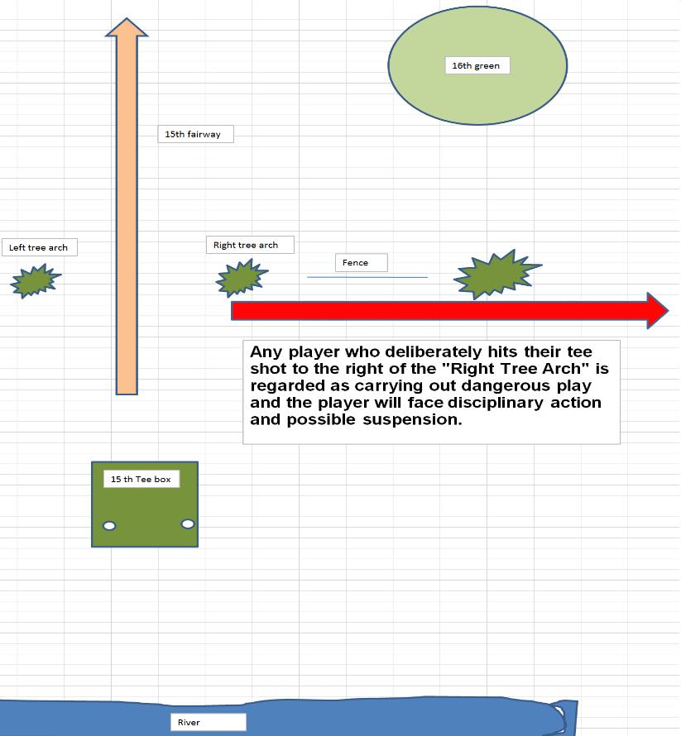

**13. 18th Hole - Out of Bounds area.**

**AIM** – To prevent dangerous play on the 18th hole by stopping people deliberately hitting directly down the 10th fairway.

Any player who deliberately hits their tee shot towards the tenth fairway is regarded as carrying out dangerous play and the player will face disciplinary action and possible suspension.

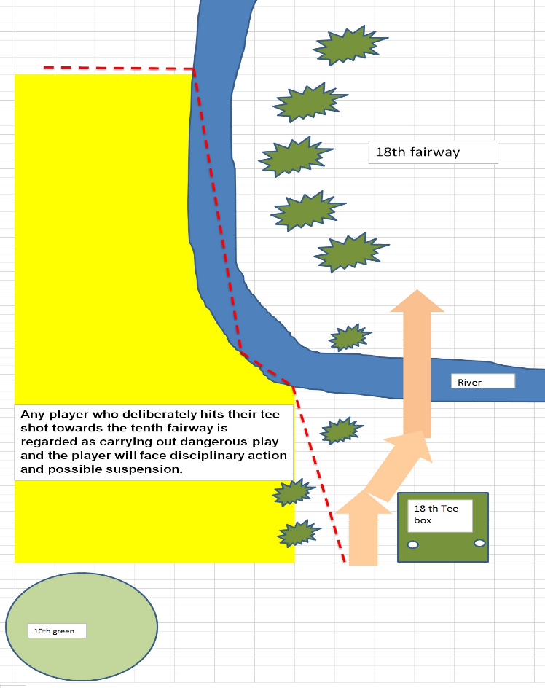

**14. Hitting the Fence on the 18th**

**Rule:** When hitting across the river on the 18th (Second river crossing for men), if your ball hits any part of the fence (chain or post) and this is seen by another player in your group, at your option (you don’t have to do this), you may play the ball again from as close to the spot from where you last played your shot, without penalty. NOTE this does not include the fence on the left of the 18th Green.

**Why**: Many players, particularly the ladies, have successfully cleared the river only to see their ball hit the fence and rebound into the river. The fence is there as people were not driving around the road but up the middle of the fairway after coming off the bridge. If we remove the fence, we feel that people will again drive up the middle of the fairway.

**SLOW PLAY**. (Rule 6-7) Player must continue without undue delay – **Your place in the field is directly behind the group in front, not in front of the group behind.**

You are encouraged to play “**READY GOLF”** throughout the course.

**When Provisional Ball Is Allowed**:

If a ball might be lost outside a penalty area or be out of bounds, to save time the player may play another ball provisionally under penalty of stroke and distance (see [Rule 14.6](https://www.randa.org/en/rog/2019/rules/the-rules-of-golf/rule-14#14-6))

Before a stroke is made, you must announce that you are going to play a ***Provisional Ball*** - you must use the word ***PROVISIONAL.***

* It is not enough for the player only to say that he or she is playing another ball or is playing again
* The player must use the word “provisional” or otherwise clearly indicate that he or she is playing the ball provisionally under [Rule 18.3](https://www.randa.org/en/rog/2019/rules/the-rules-of-golf/rule-18#18-3).

If the player does not announce this (even if he or she intended to play a provisional ball) and plays a ball from where the previous stroke was made, that ball is the player’s ball in play under penalty of stroke and distance (see [Rule 18.1](https://www.randa.org/en/rog/2019/rules/the-rules-of-golf/rule-18#18-1)).

On the Putting Green, you may remove sand and loose soil, repair damage and take free relief from interference by animal holes, ground under repair, immovable obstructions or temporary water.



